

|  |  |
| --- | --- |
| **ASSIGNMENT** | |
| **Course Code** | CSC201A |
| **Course Name** | Discrete Mathematics -1 |
| **Programme** | B. Tech |
| **Department** | Computer Science & Engineering |
| **Faculty** | Faculty of Engineering Technology |

#### 

|  |  |
| --- | --- |
| **Name of the Student** | SUBHENDU MAJI |
| **Reg. No** | 18ETCS002121 |
| **Semester/Year** | 3RD / 2019 |
| **Course Leader/s** | Ms Sahana P. Shankar |

|  |  |  |  |  |  |  |  |  |
| --- | --- | --- | --- | --- | --- | --- | --- | --- |
| **Declaration Sheet** | | | | | | | | |
| Student Name | SUBHENDU MAJI | | | | | | | |
| Reg. No | 18ETCS002121 | | | | | | | |
| Programme | B. Tech | | | | | Semester/Year | 3rd / 2019 | |
| Course Code | CSC201A | | | | | | | |
| Course Title | Discrete Mathematics -1 | | | | | | | |
| Course Date |  | | To | |  | | | |
| Course Leader | Ms Sahana P. Shankar | | | | | | | |
| **Declaration**  The assignment submitted herewith is a result of my own investigations and that I have conformed to the guidelines against plagiarism as laid out in the Student Handbook. All sections of the text and results, which have been obtained from other sources, are fully referenced. I understand that cheating and plagiarism constitute a breach of University regulations and will be dealt with accordingly. | | | | | | | | |
| Signature of the Student | |  | | | | | Date |  |
| Submission date stamp  (by Examination & Assessment Section) | |  | | | | | | |
| Signature of the Course Leader and date | | | | Signature of the Reviewer and date | | | | |
|  | | | |  | | | | |

# **Contents**

____________________________________________________________________________

**Declaration Sheet** ii

**Contents** iii

Marking Scheme iv

**Question No. 1** 5

1.1 Development of a Python program with comments to create sets and perform the specified operations 5

1.2 Illustration using Venn diagrams 7

**Question No. 2** 9

2.1 Justification of the statement with appropriate reasoning 9

2.2 Solution to the example problem 10

Bibliography 11

|  |  |  |  |
| --- | --- | --- | --- |
| Engineering and Technology | | | |
| Ramaiah University of Applied Sciences | | | |
| Department | Computer Science and Engineering | Programme | B. Tech. |
| Semester/Batch | 3rd/2019 | | |
| Course Code | CSC201A | Course Title | Discrete Mathematics-1 |
| Course Leader(s) | Ms Sahana P. Shankar and Ms.Supriya | | |

|  |  |  |  |  |  |
| --- | --- | --- | --- | --- | --- |
|  | | | | | |
| Questions | Marking Scheme | | Marks | | |
| Max Marks | First Examiner Marks | Moderator |
| 1 |  | | | | |
| 1.1 | Development of a Python program with comments to create sets and perform the specified operations | 5 |  |  |
| 1.2 | Illustration using Venn diagrams | 2 |  |  |
| **Question 1 Max Marks** | | **7** |  |  |
| 2 |  | | | | |
| 2.1 | Justification of the statement with appropriate reasoning | 2 |  |  |
| 2.2 | Solution to the example problem | 1 |  |  |
| **Question 2 Max Marks** | | **3** |  |  |
| **Total Assignment Marks** | | | 10 |  |  |

|  |  |  |  |  |
| --- | --- | --- | --- | --- |
| **Course Marks Tabulation** | | | | |
| **Question** | **First Examiner** | **Remarks** | **Moderator** | **Remarks** |
| 1 |  |  |  |  |
| 2 |  |  |  |  |
| **Marks (Max 10 )** |  |  |  |  |
| **Signature of First Examiner Signature of Moderator** | | | | |

# **Question No. 1**

**Solution to Question No. 1:**

## Development of a Python program with comments to create sets and perform the specified operations

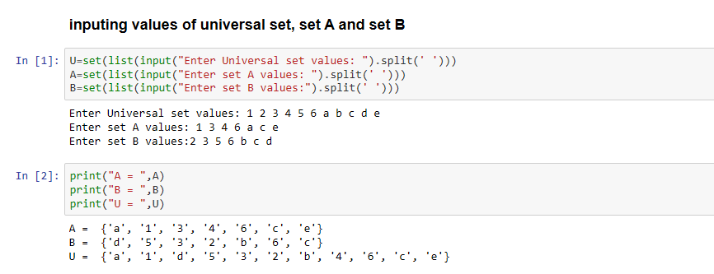

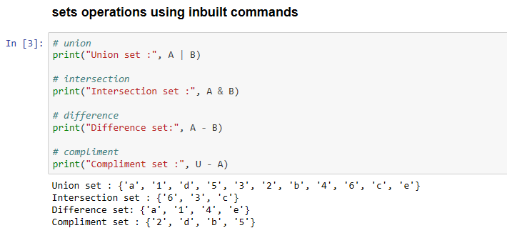

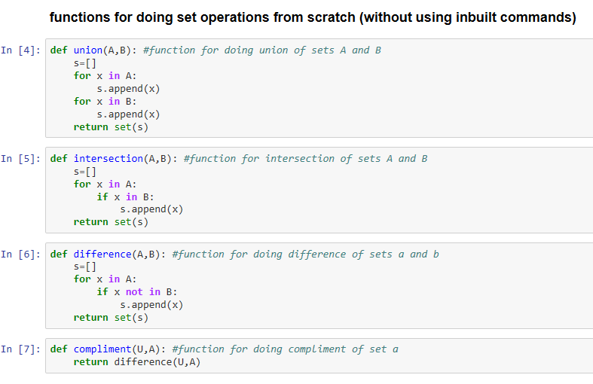

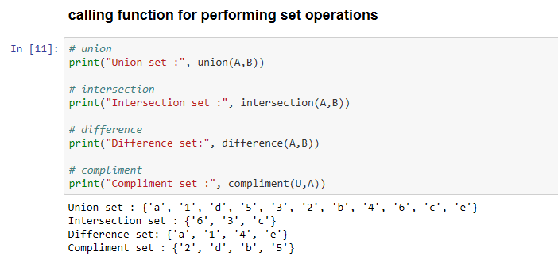

## Illustration using Venn diagrams

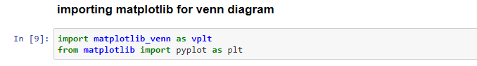

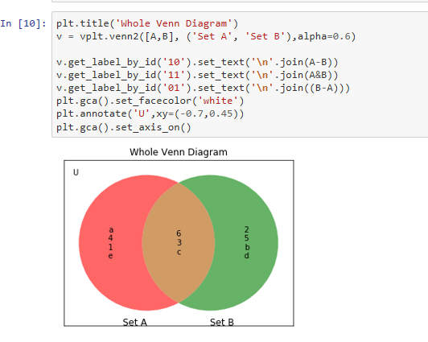

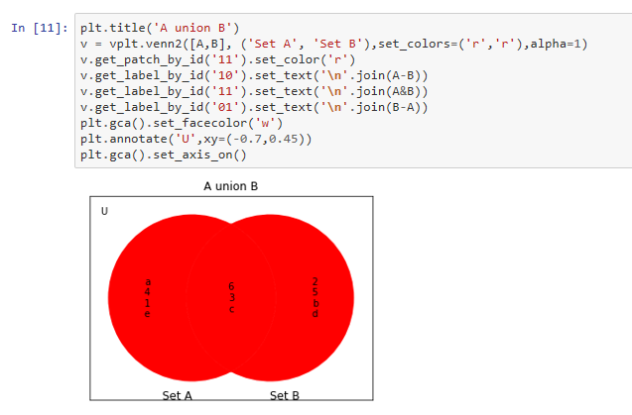

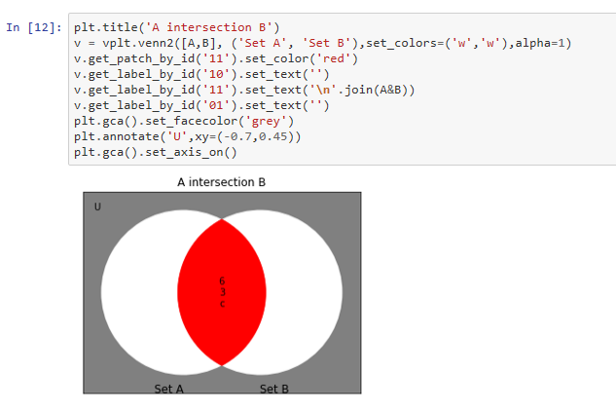

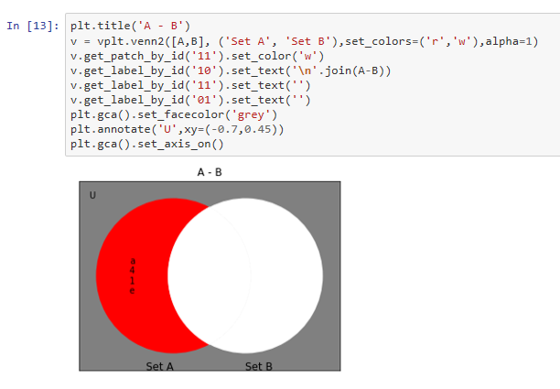

# **Question No. 2**

**Solution to Question No. 2:**

## 2.1 Justification of the statement with appropriate reasoning

**“Mathematical Induction can be applied to prove that the cardinality of a power set is 2n,**

**where n is the cardinality of the set”**

Yes, the statement is True.

**To Prove:** For any finite set S, if , then has subsets.

**Proof:**

Let P(n) be the predicate “A set with cardinality n has 2n subsets”.

**Basis step:**

is true, because the set with cardinality 0 (the empty set) has 1 subset (itself) and .

**Inductive step:** To Prove

That is, prove that if a set with k elements has 2k subsets, then a set with elements has subsets.

**Proof**

Assume that for an arbitrary , any set with cardinality has subsets.

Let be a set such that .

Enumerate the elements of

Let

Then , so has subsets, according to the inductive hypothesis.

Note that , so every subset of is also a subset of .

Any subset of either contains the element , or it doesn’t contain .

If a subset of doesn’t contain, then it is also a subset of , and there are of those subsets.

On the other hand, if a subset of does contain the element , then that subset is formed by including in one of the subsets of , so has subsets containing .

We have shown that has subsets containing , and another subsets not containing , so the total number of subsets of is **.**

## 2.2 Solution to the example problem

Example.

Let be a set,

Cardinality of is given by , hence **|S|=4**

Subsets of:

Hence the

Therefore, the power set will be the set of all subsets

i.e. its cardinality is equal to total number of subsets, .

# Bibliography

* <https://www.math.fsu.edu/~wooland/mad2104/proof/pf20.pdf>
* <https://stackoverflow.com/questions/54603761/is-it-possible-to-display-the-venn-diagram-within-a-universal-set>

For Python Source Code:

* <https://github.com/subhendu17620/RUAS/blob/master/sem%2003/DM-1/DM-assignment01.ipynb>

<https://github.com/subhendu17620>